Module–1(Fundamental)

1. What is SDLC?

* SDLC(software development life cycle) is step by step process that shows the software development product like requirement gathering, analysis, design, implementation, testing, maintenance.

1. What is software testing?

* Software testing is a process used to identify correctness, completeness, and quality of developed computer software.

1. What is agile methodology?

* Agile SDLC model is combination of iterative and incremental process model. And mainly focused with adaptability and customer satisfaction by fast delivery of working software product.

1. What is SRS

* Software requirement specification(SRS) is a complete description of the system to be developed.

1. What is oops

* Object oriented programming system.

1. Write Basic Concepts of oops

* Object, class, encapsulation, inheritance, polymorphism, abstraction.

1. What is object

* Object is an instances of class.

1. What is class

* Class is an collection of data member and member function with its behaviour.

1. What is encapsulation

* Wrapping of data into single unit.

1. What is inheritance

* Properties of parent class extends into child class.

1. What is polymorphism

* Ability of one name having many forms.

1. Draw Usecase on online bill payment system (paytm)

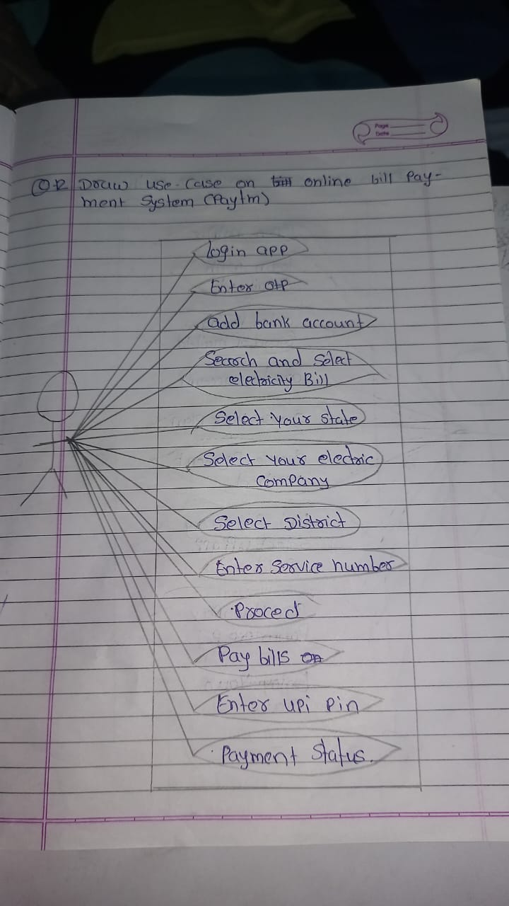

1. Draw Usecase on banking system for customers.

* 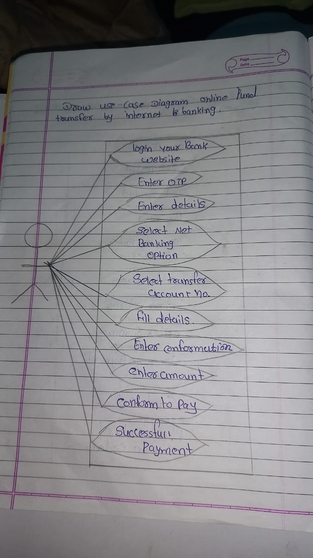

1. Draw Usecase on Broadcasting System.
2. Write SDLC phases with basic introduction

* Phases of SDLC :-

requirement gathering:-knowing the needs of customers.

Analysis:- discussion of how much time taken through the project.

Design:- designing of diagram or structure of project.

Implementation:- writing the code.

Testing:-testing of developed project.

Maintenance:-repairing the defects and find the solution for new requirements.

1. Explain Phases of the waterfall model

* Phases of waterfall:- requirement gathering, analysis, design, implementation, testing, maintenance.

1. Write phases of spiral model

* Phases of spiral model:- requirement gathering, analysis, design, implementation, testing, maintenance.

1. Write agile manifesto principles

* There are 4 types of manifesto:-

1.indiviual interaction

2.customer collaboration

3.working software

4.responding to change

1. Explain working methodology of agile model and also write pros and cons.

* Agile Methods break the product into small incremental builds.
* These builds are provided in iterations.
* Each iteration typically lasts from about one to three weeks.

**Pros.**

1.Is a very realistic approach to software development.

2. promotes teamwork and cross training.

3.resource requirement are minimum.

4. suitable for fixed or changing requirements.

**Cons.**

1. Not suitable for handling complex dependencies.
2. More risk of sustainability, maintainability and extensibility.

3.Depends heavily on customer interaction, so if customer is not clear, team can be driven in the wrong direction.

4. There is very high individual dependency, since there is minimum documentation generated.

1. Draw usecase on OTT Platform.

* 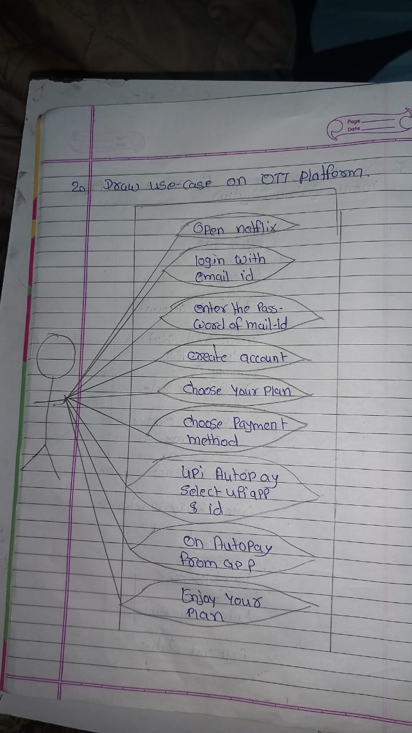

1. Draw usecase on E-commerce application

* 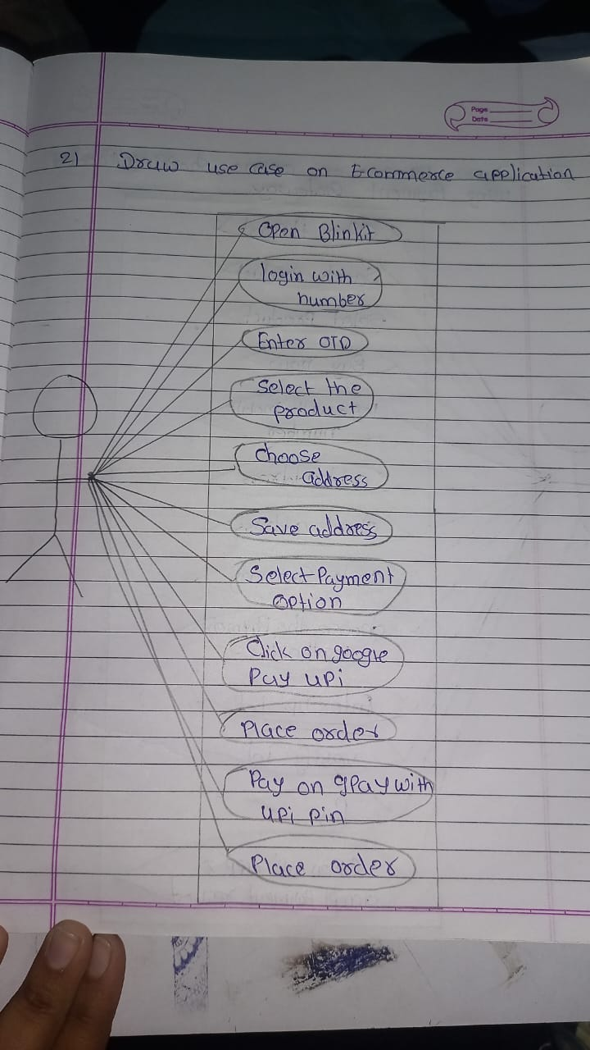

1. Draw usecase on Online shopping product using payment gateway

* 